**Your Medic Hospital**

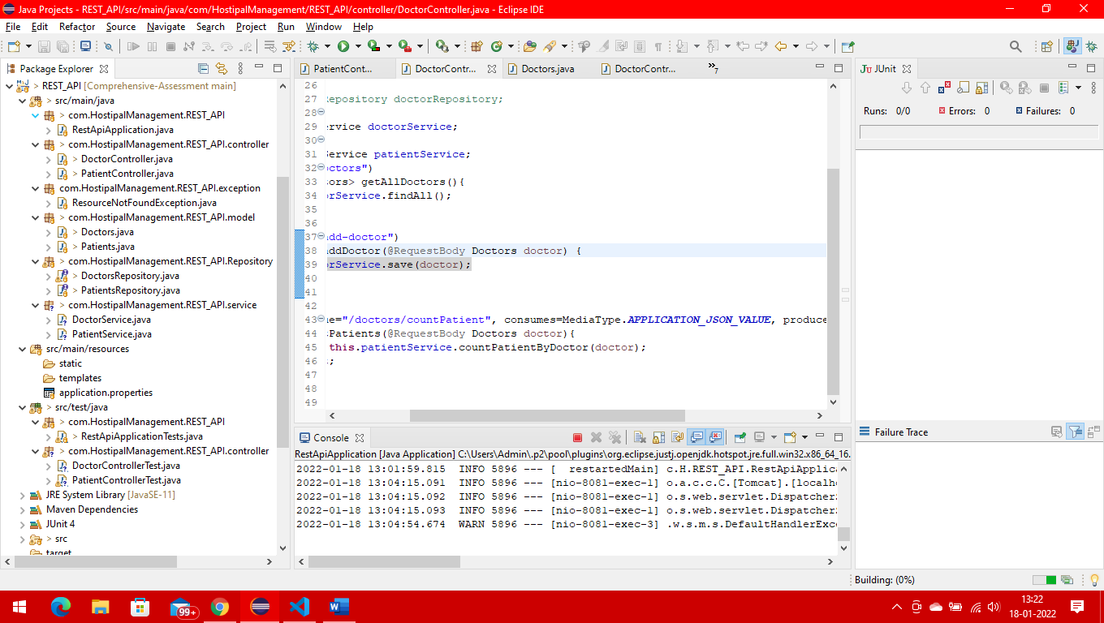

Folder structure of the backend rest api

1. Create doctor information.

Controller class

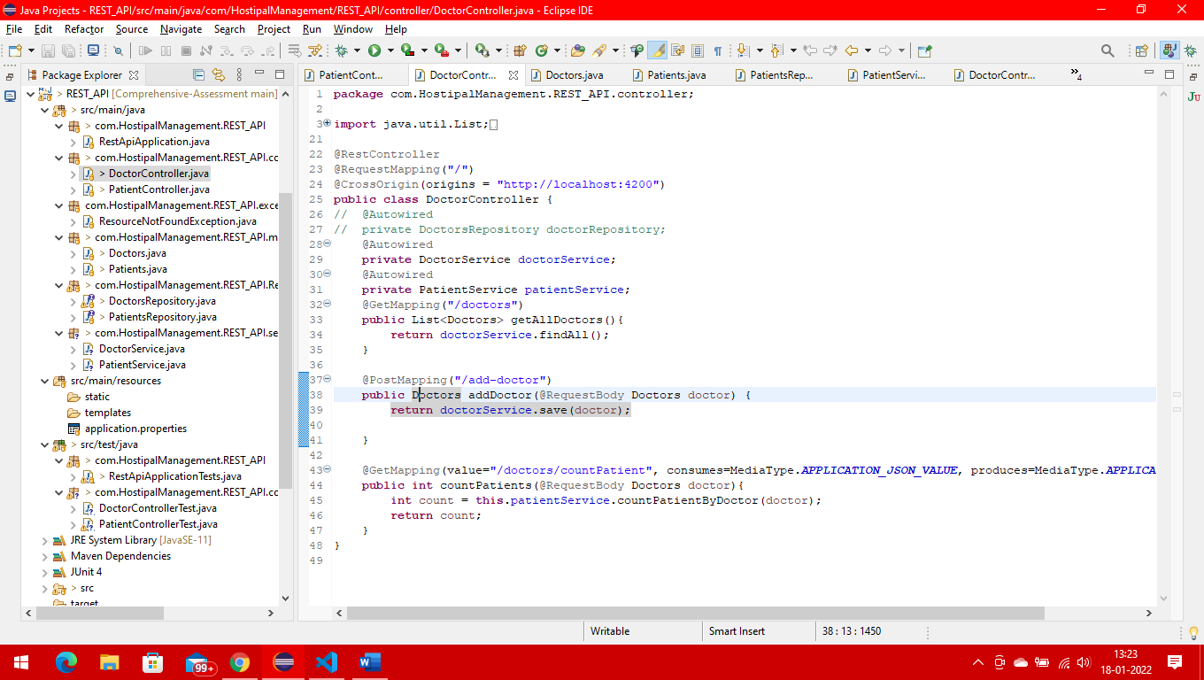

Doctor entity

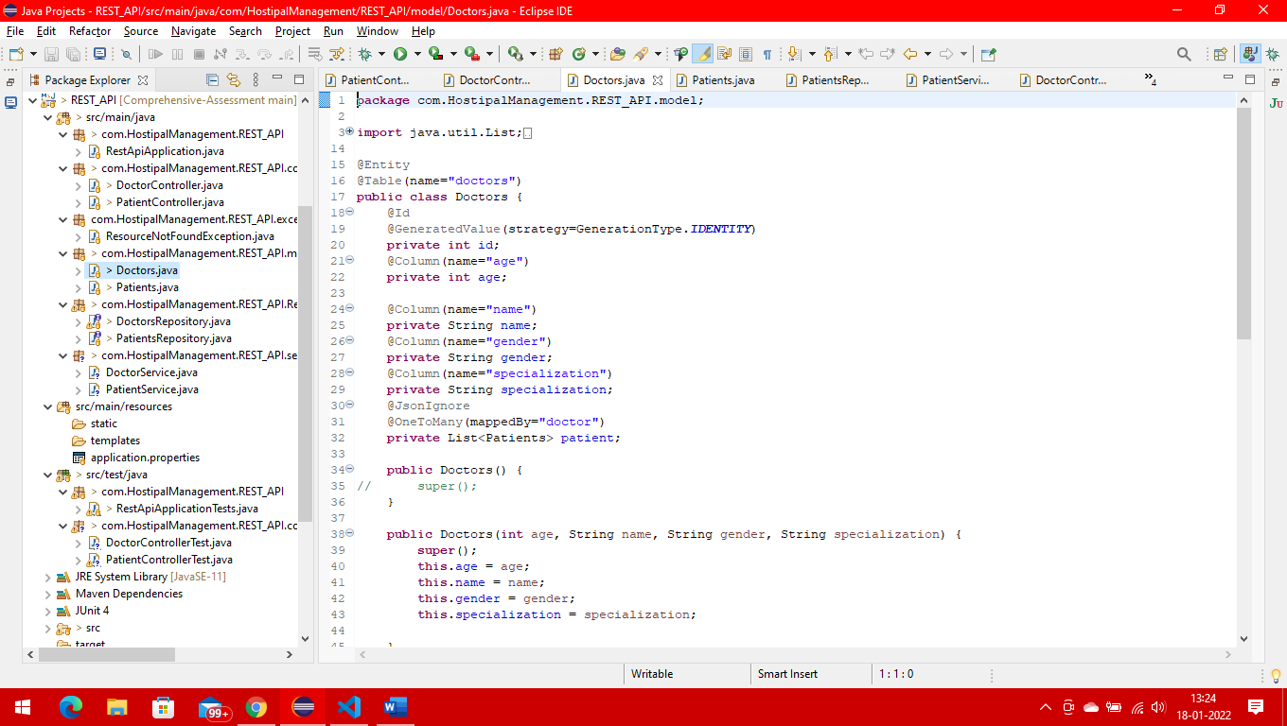

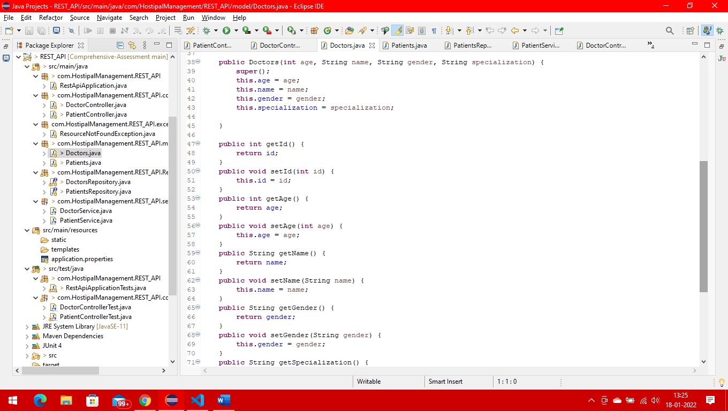

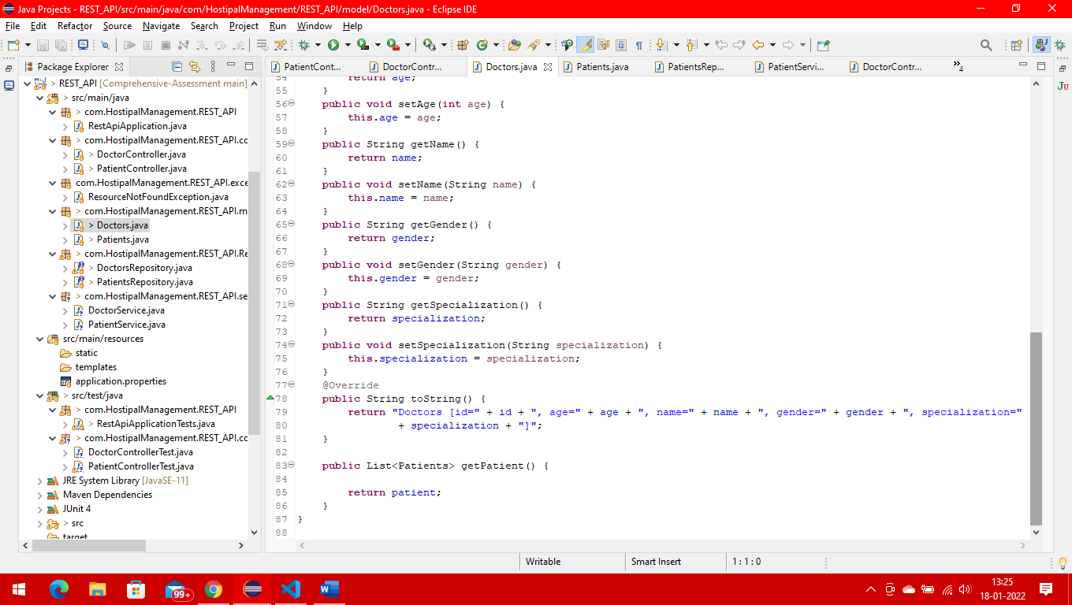

Doctor repository

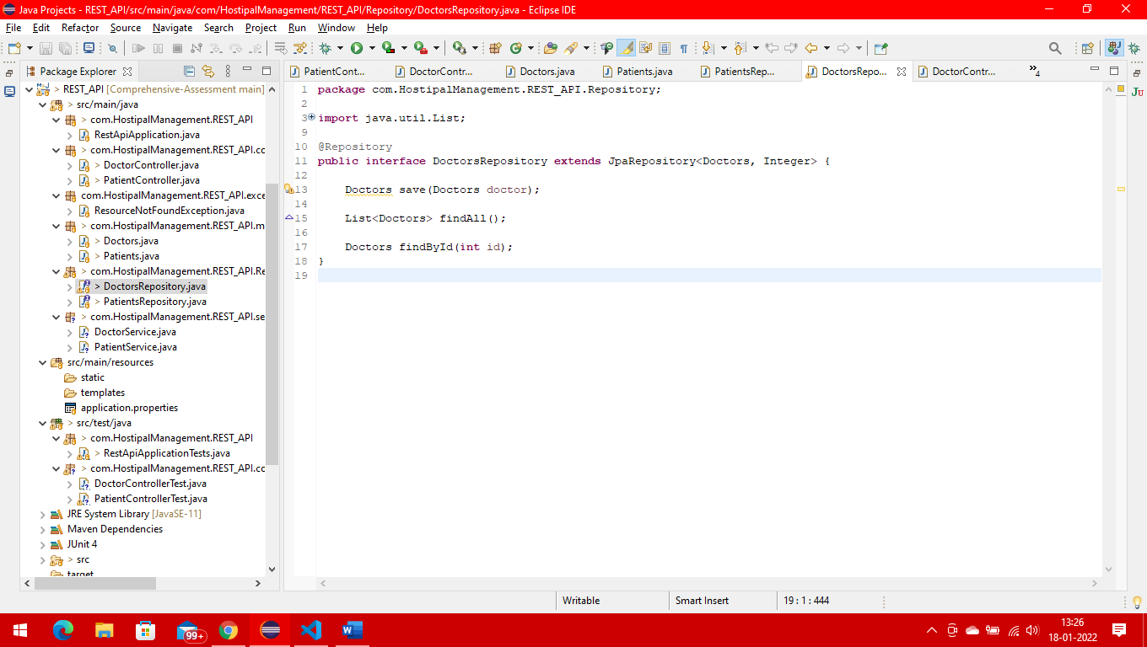

Doctor Service

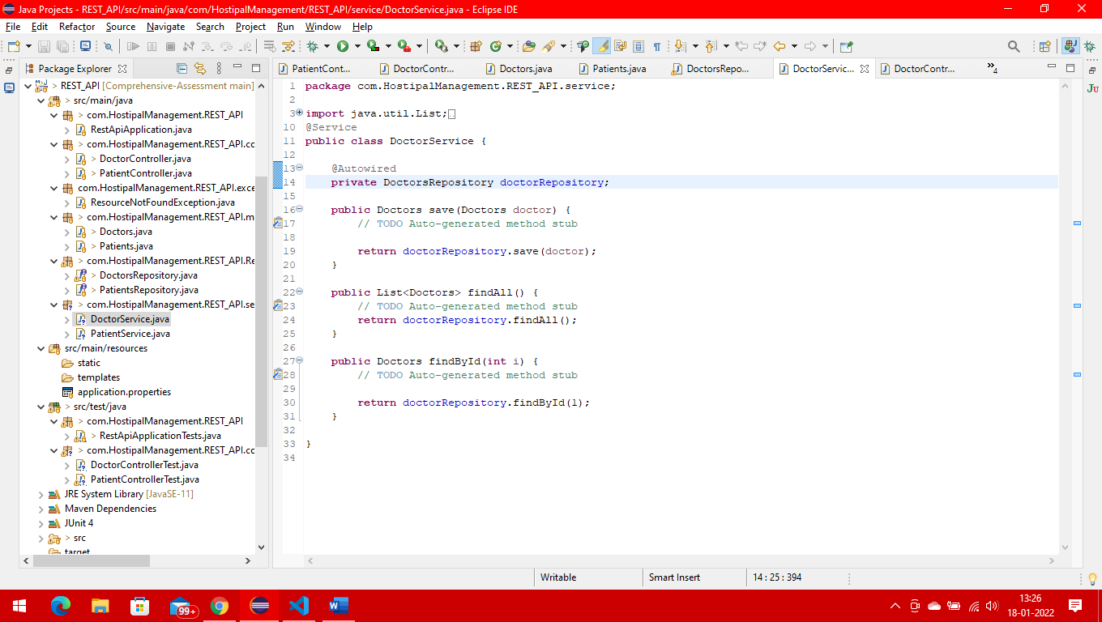

**FRONT END PART**

Doctor class

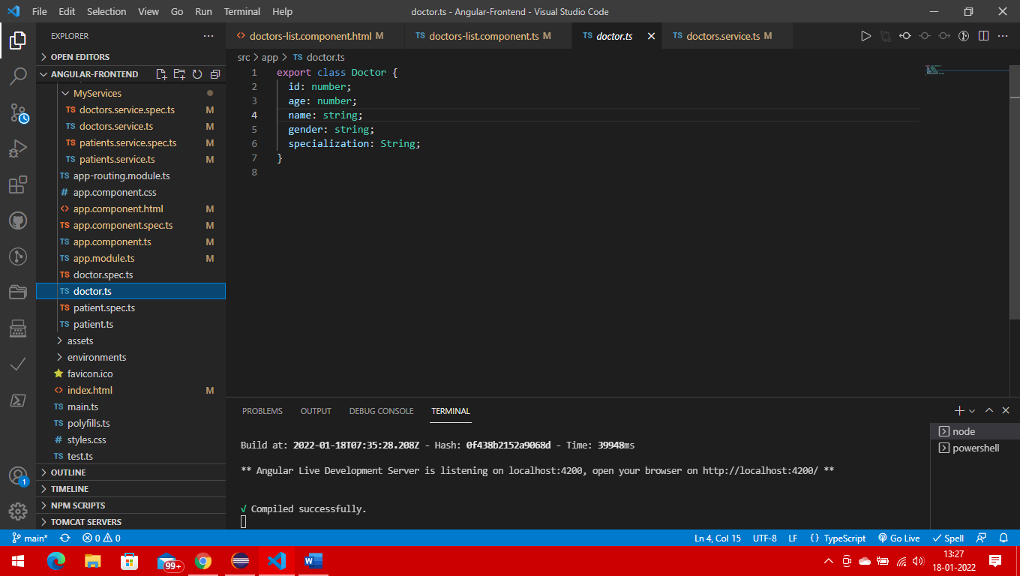

Doctor service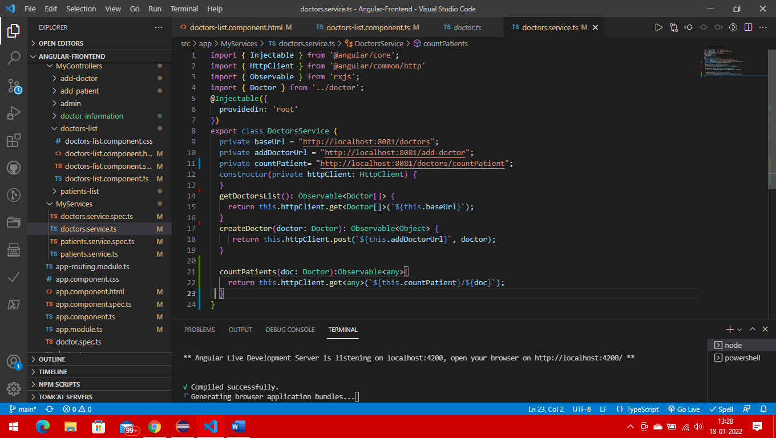

1. Create patient information . In patient creation page there should be one dropdown box where user needs to select a doctor name from the dropdown box.

Patient controller

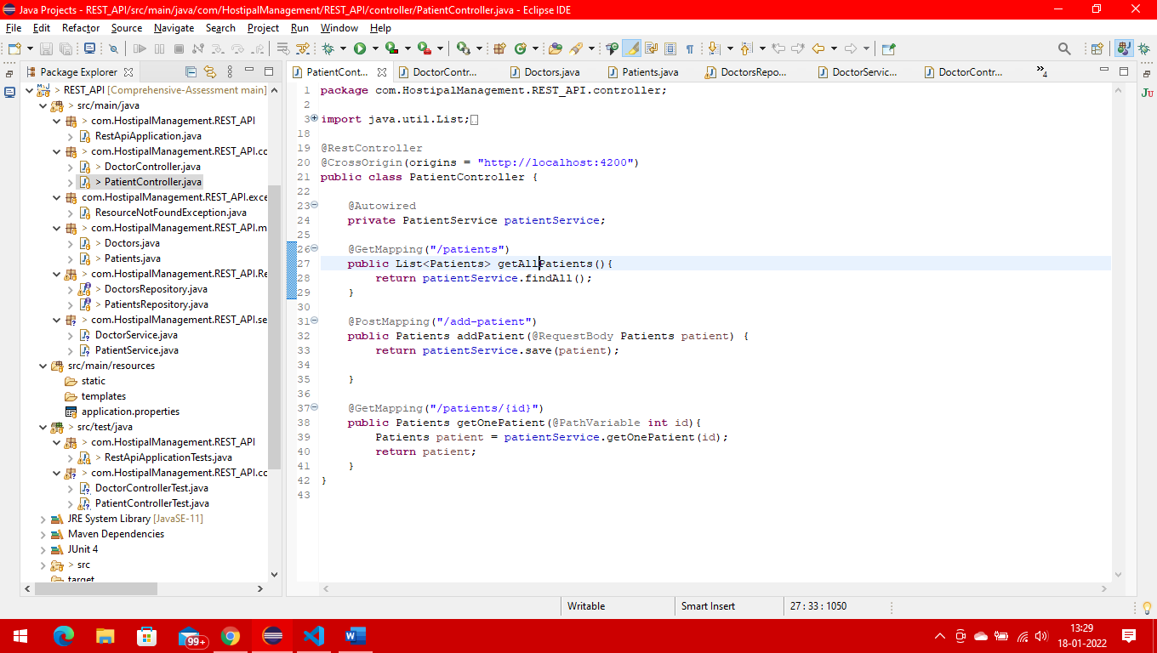

Patient repository

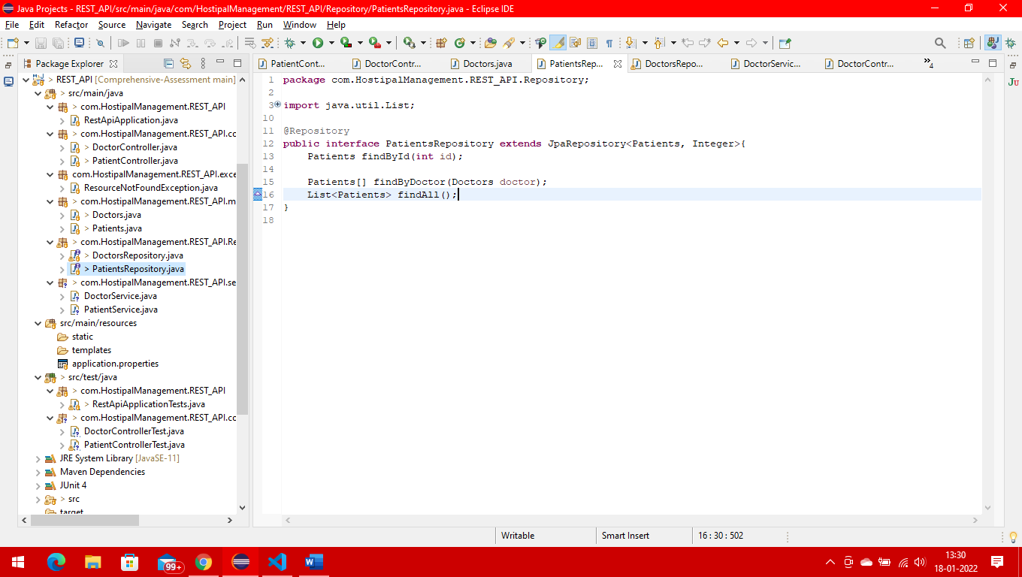

Patient entity

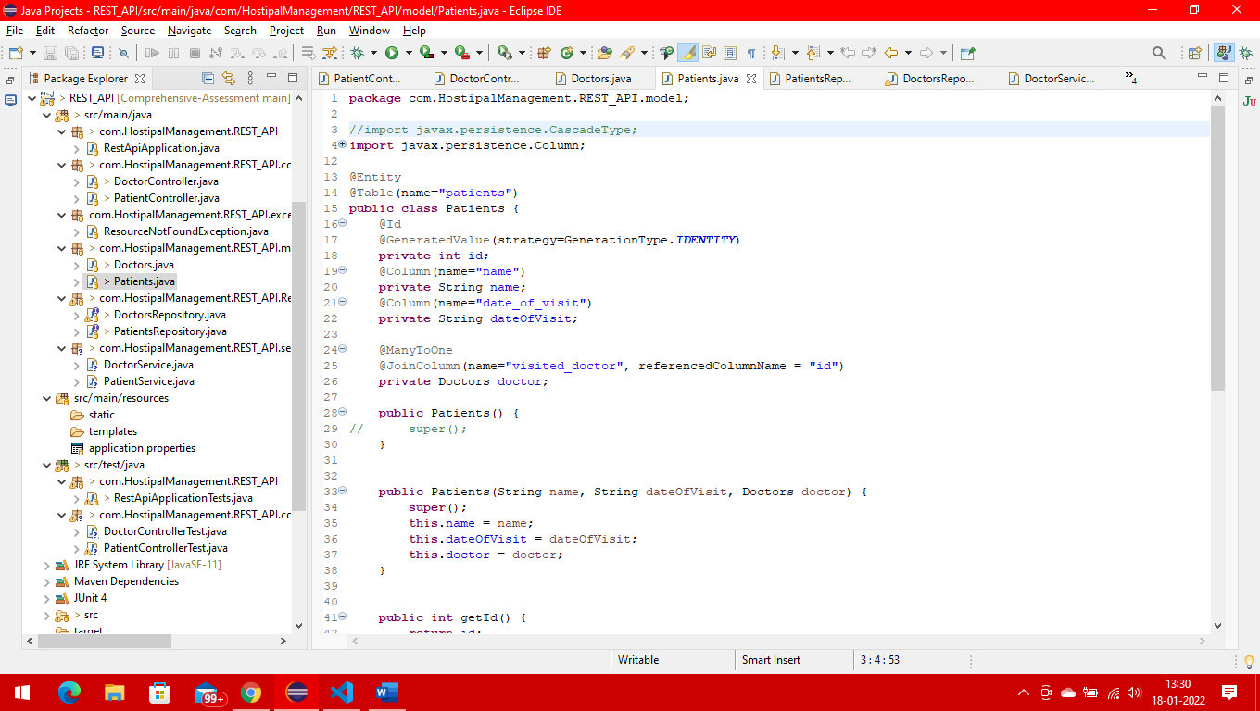

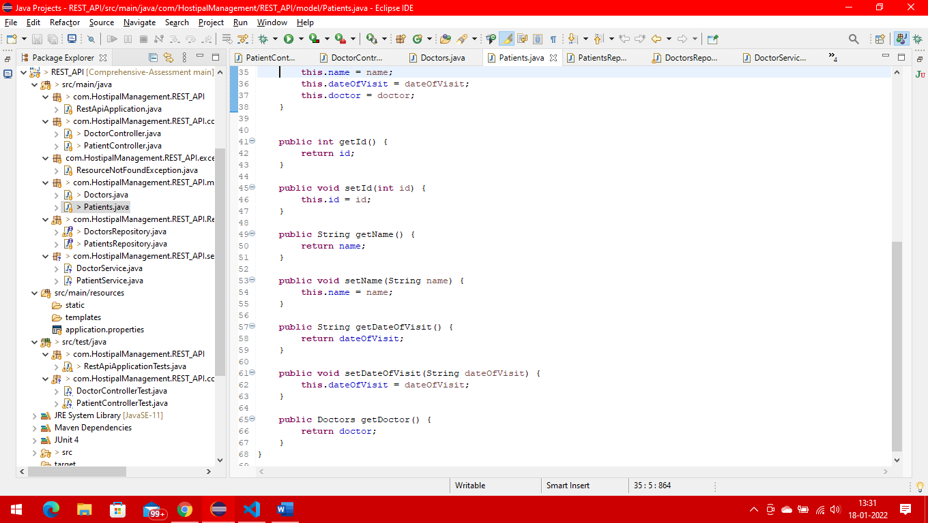

Patient Service

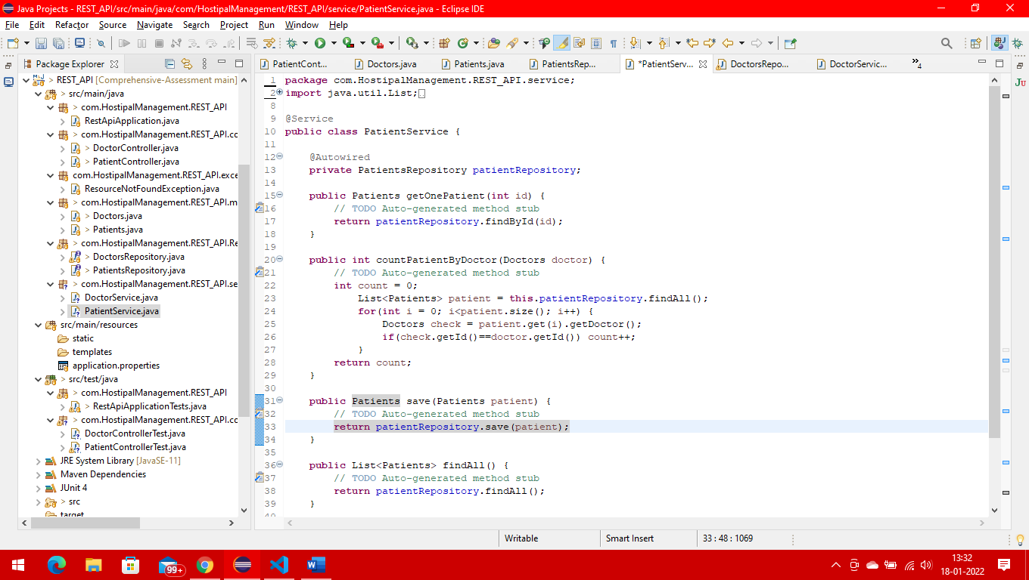

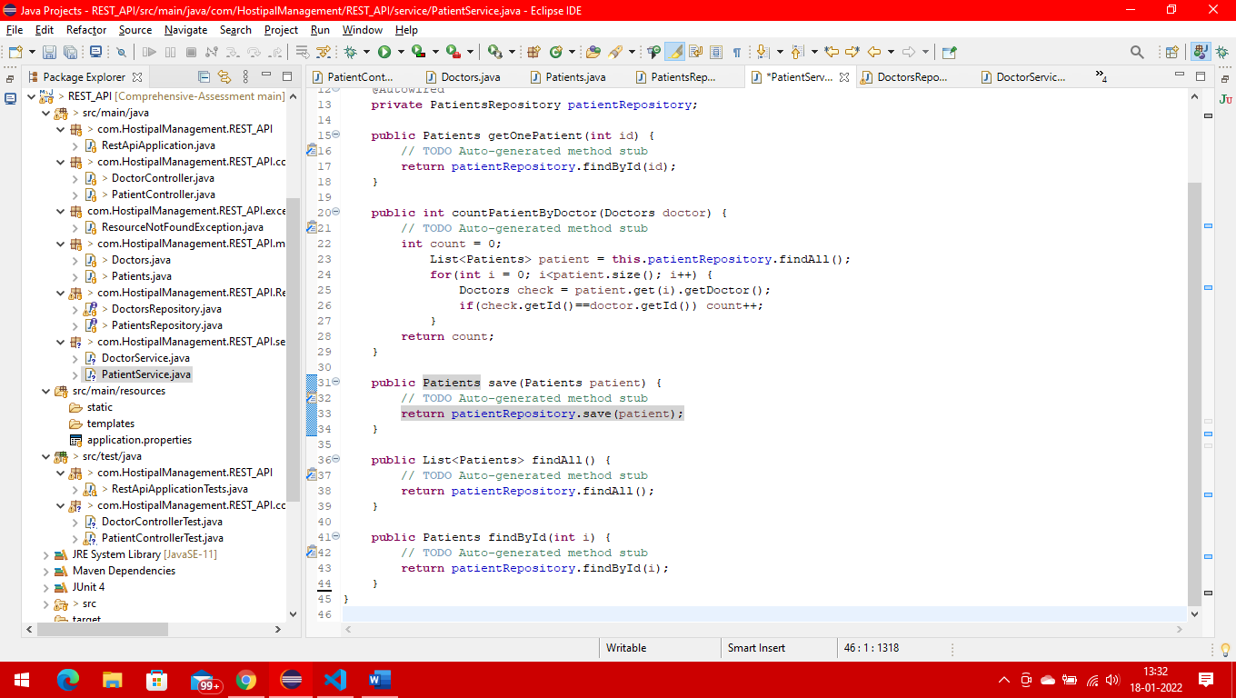

FRONT END CODE

Patient

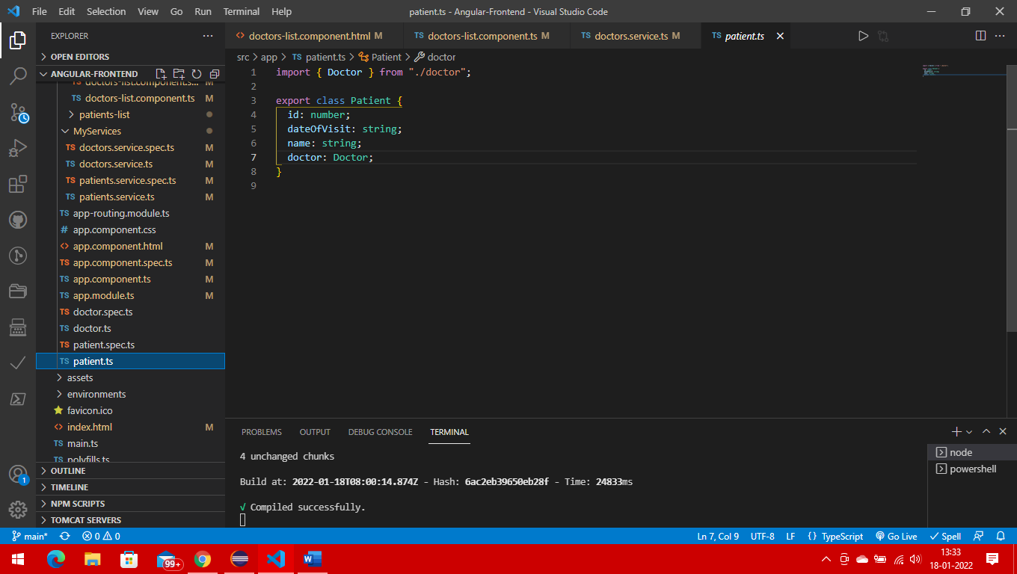

Patient service

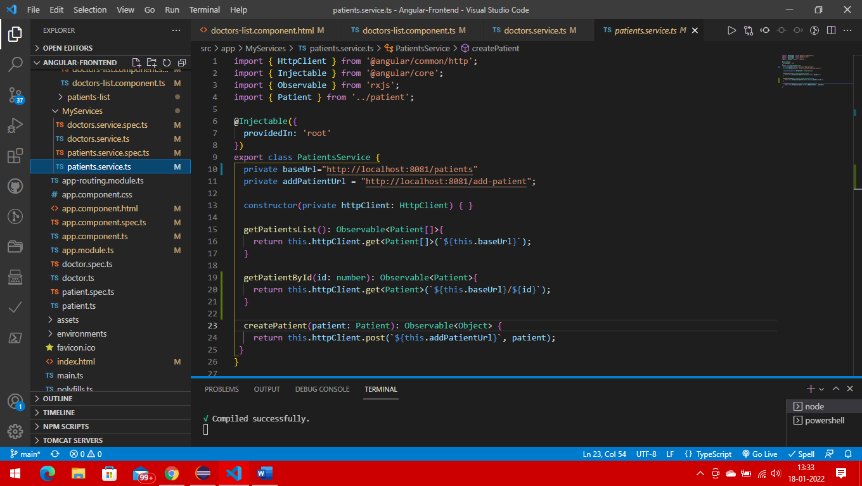

Patient Creation Page

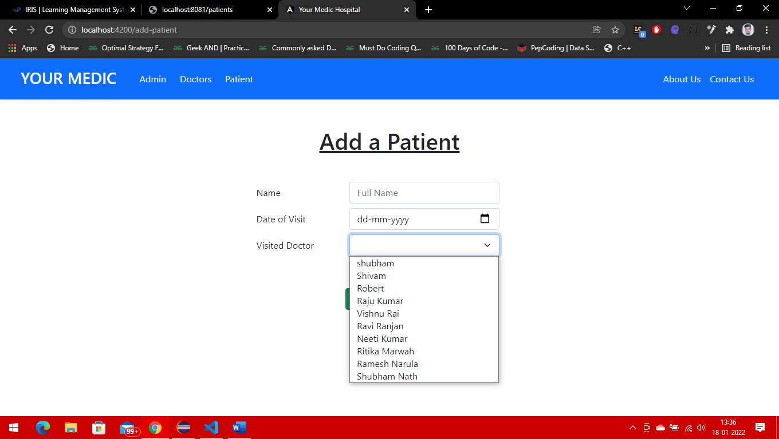

Code

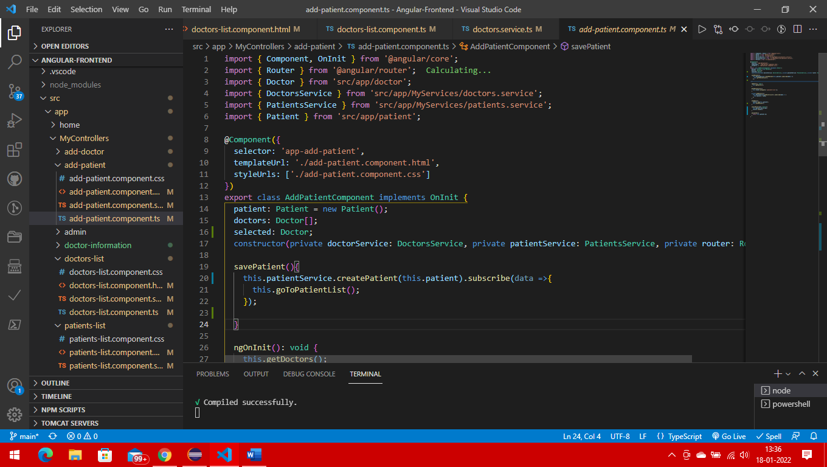

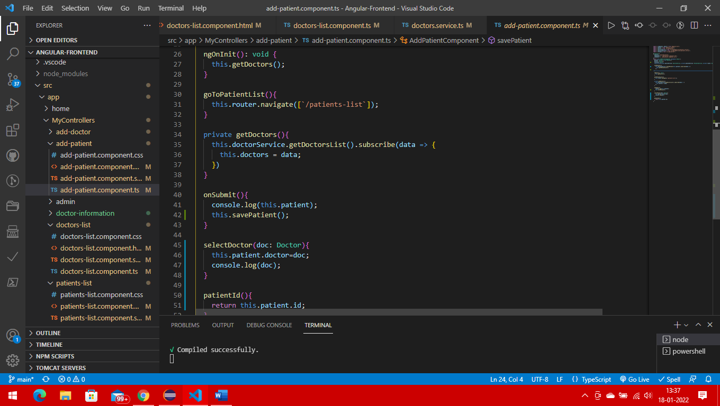

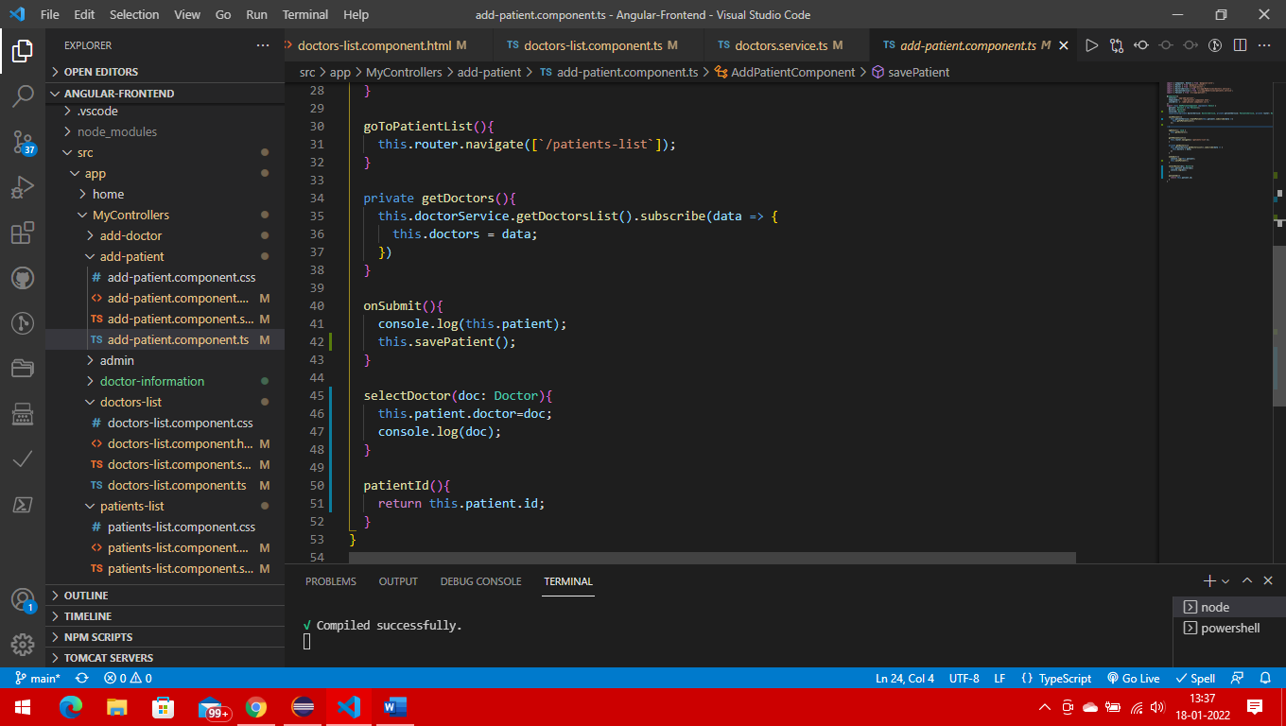

After adding the patient it will be redirected to the patient display page

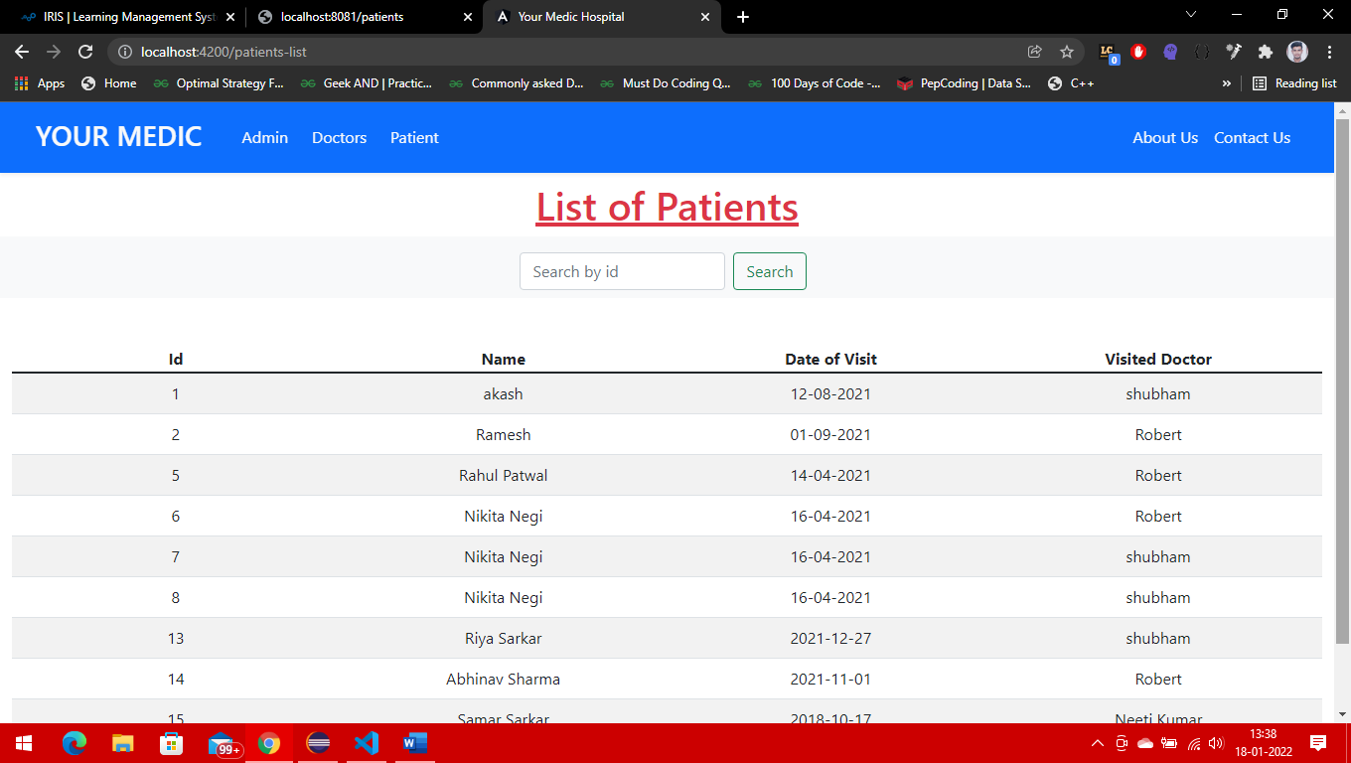

Code

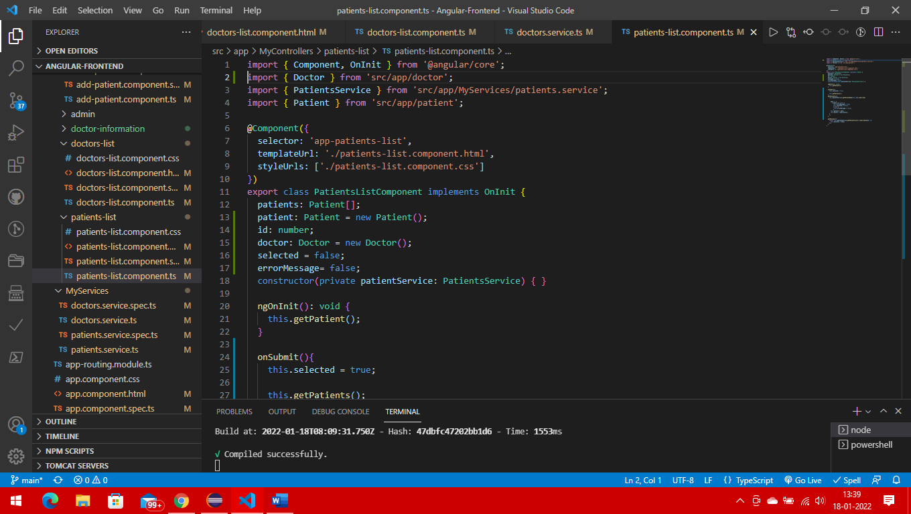

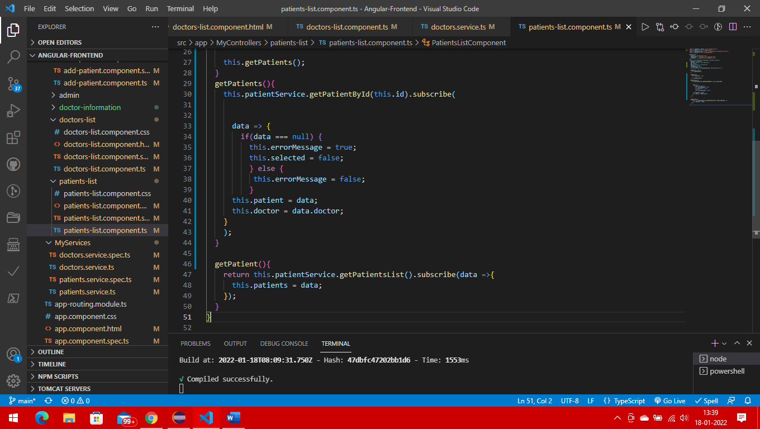

1. Crate a tab for ShowDoctorInformation. Once user clicks on the showDoctorInformation page a new page will display where there is one dropdown box named as selectDoctor. Once User clicks on and select a doctor name from the dropdown box , it will display the doctor’s information as table in the same page. It show doctorname, specializationfiled and numberOfpatientAttneded.

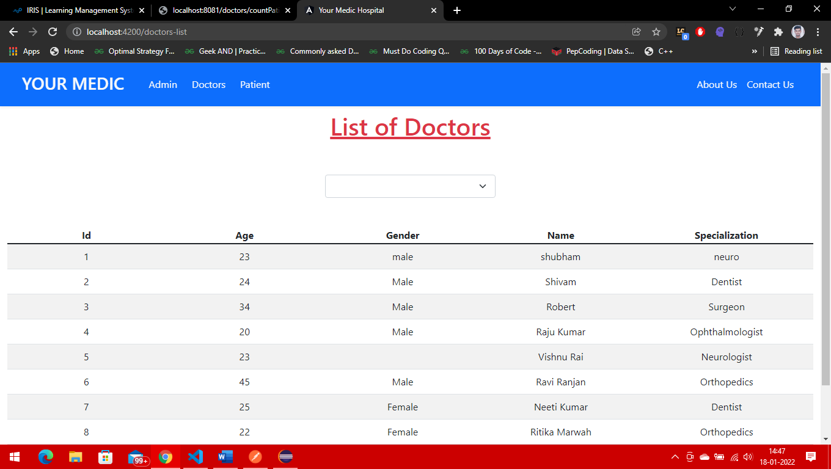

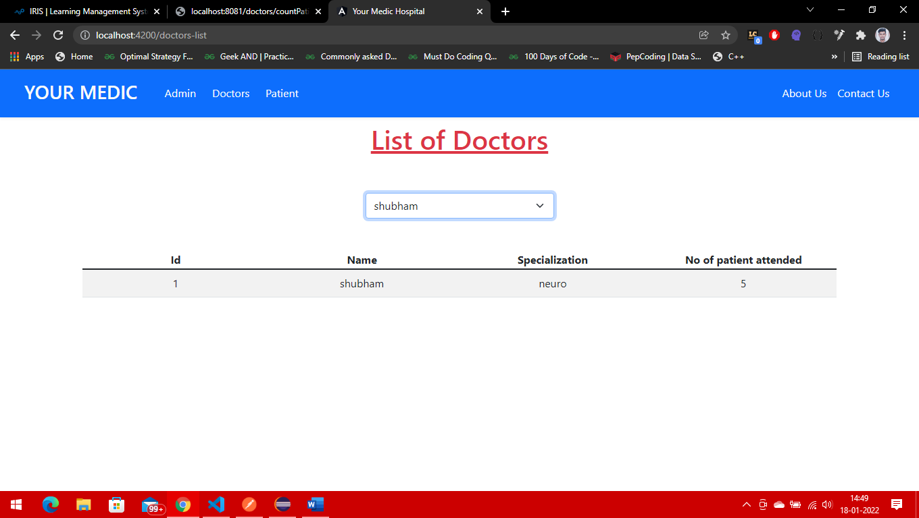

1. 4. In show patient information tab once the user enter patient ID in a text box it will display the patient data like patient name, age, visitedDoctorName, dataOfVist and also the doctor’s prescription. If there is no patient ID in the database then it will display an error page “ No such patient there in the database.

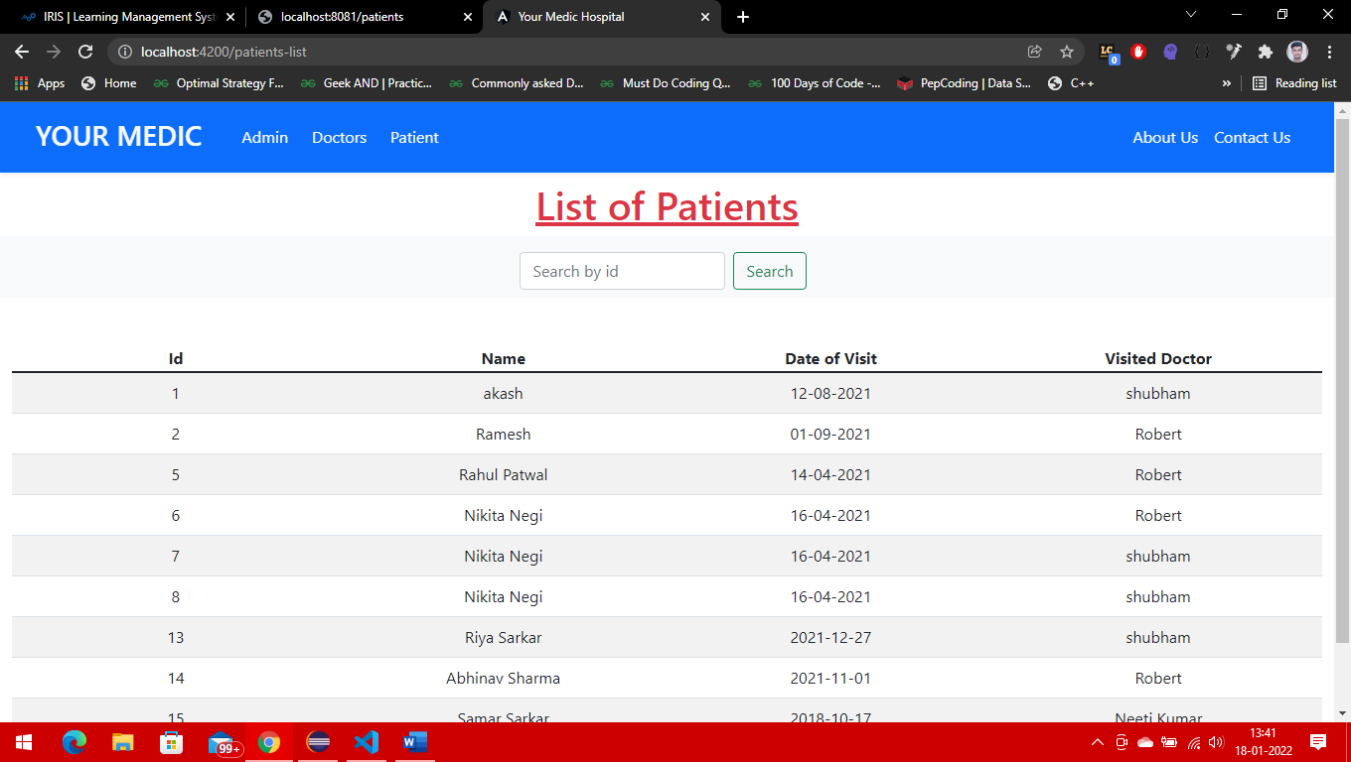

When user enter the valid id

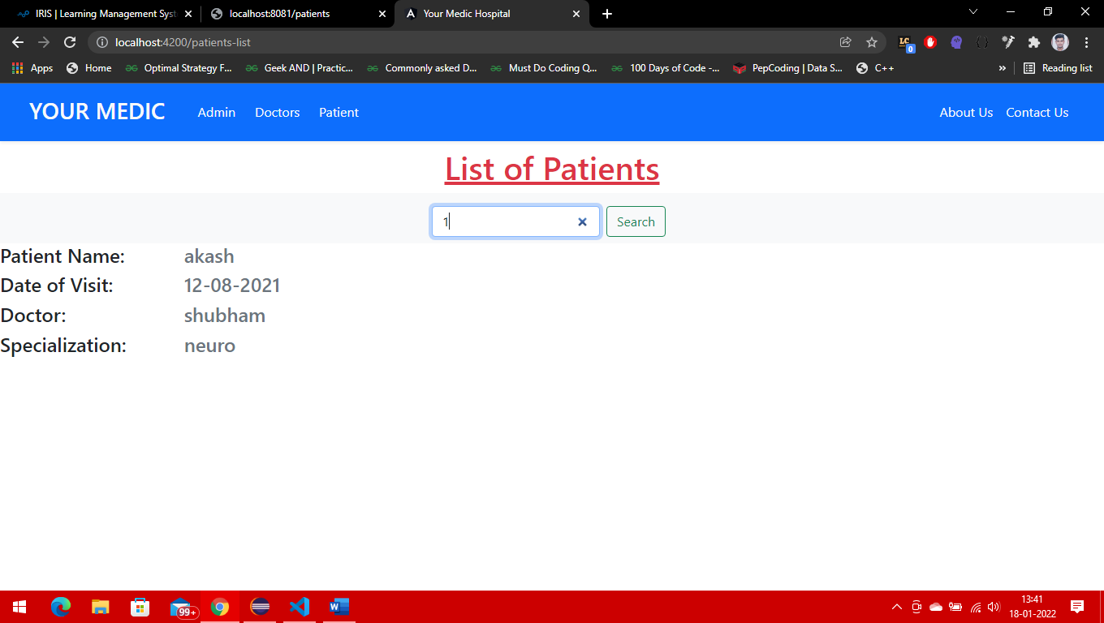

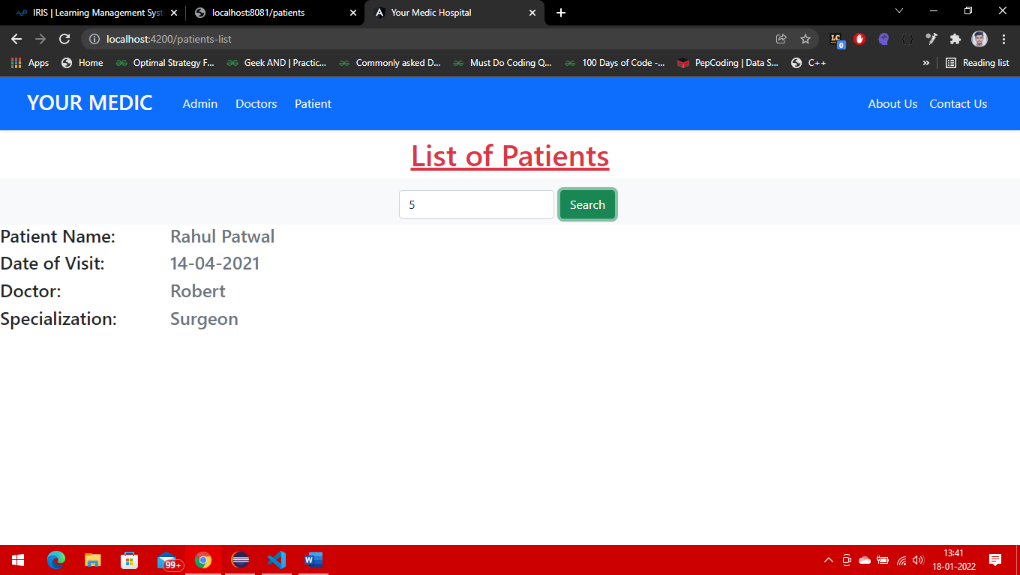

When user insert a invalid id

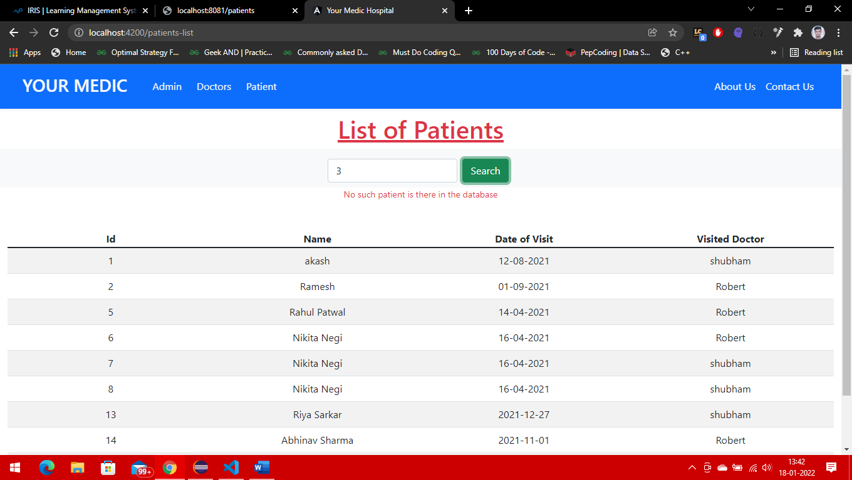

1. Based on the above scenario create an java application where the UI design and page navigation should be developed by Angular . Through Springboot RESTAPI backend database (MySQL) should be interacted. Angular to Springboot REST api should be interacted.

Databases in hospital_management

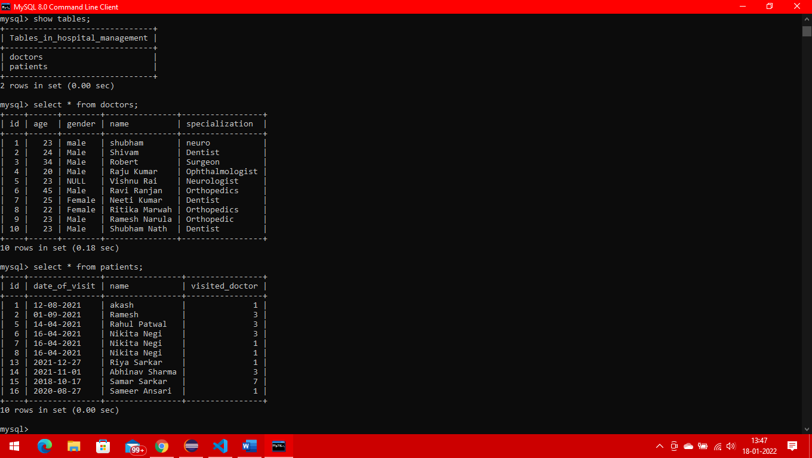

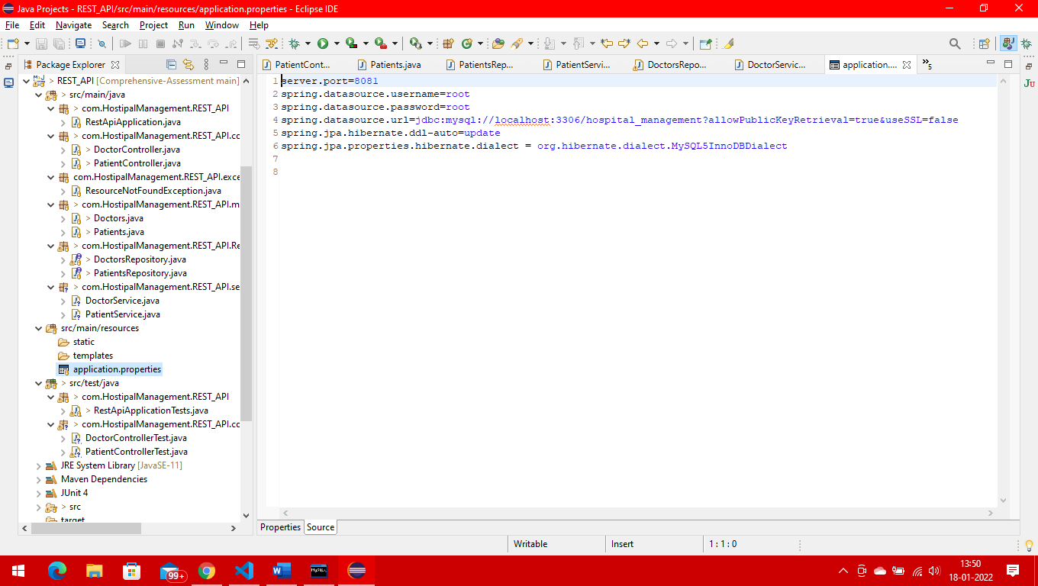

1. After development of the application make maven build and produce a jar file in target folder. Commit and push the code into GIT hub repository. Make Jenkins integration with GitHub repository. So that there should be continuous deployment should be achieved.

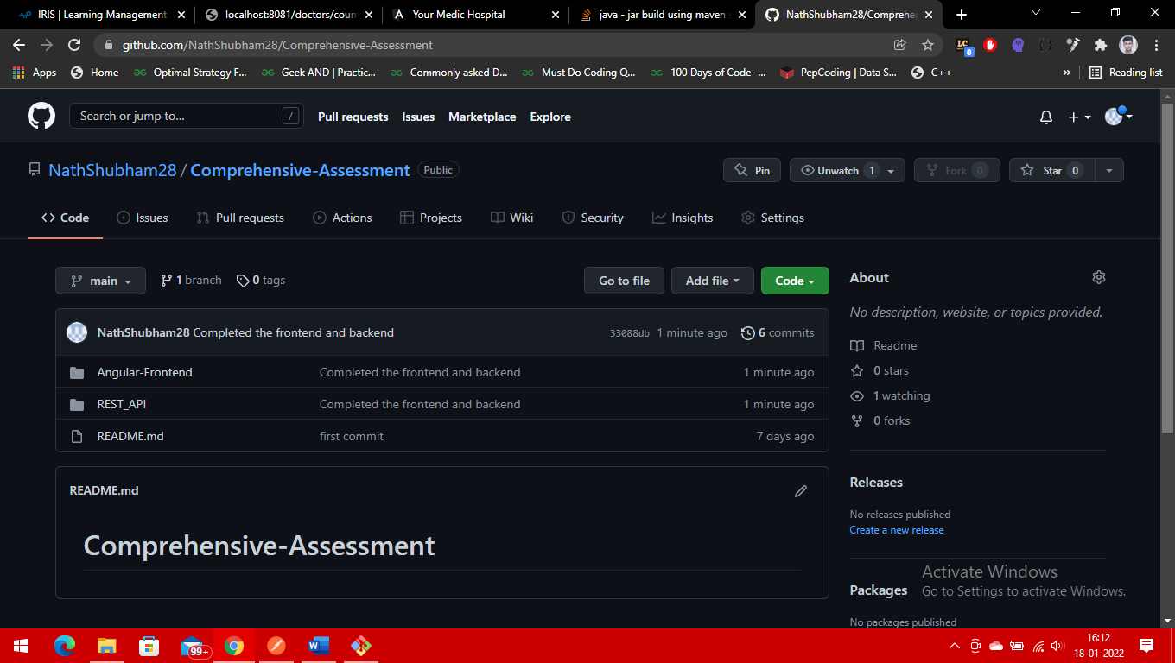

1. Use proper Bootstrap and CSS for page designing. Use Angular’ s page routing for navigating to various tabs.

Home page designed by me using bootstrap and css

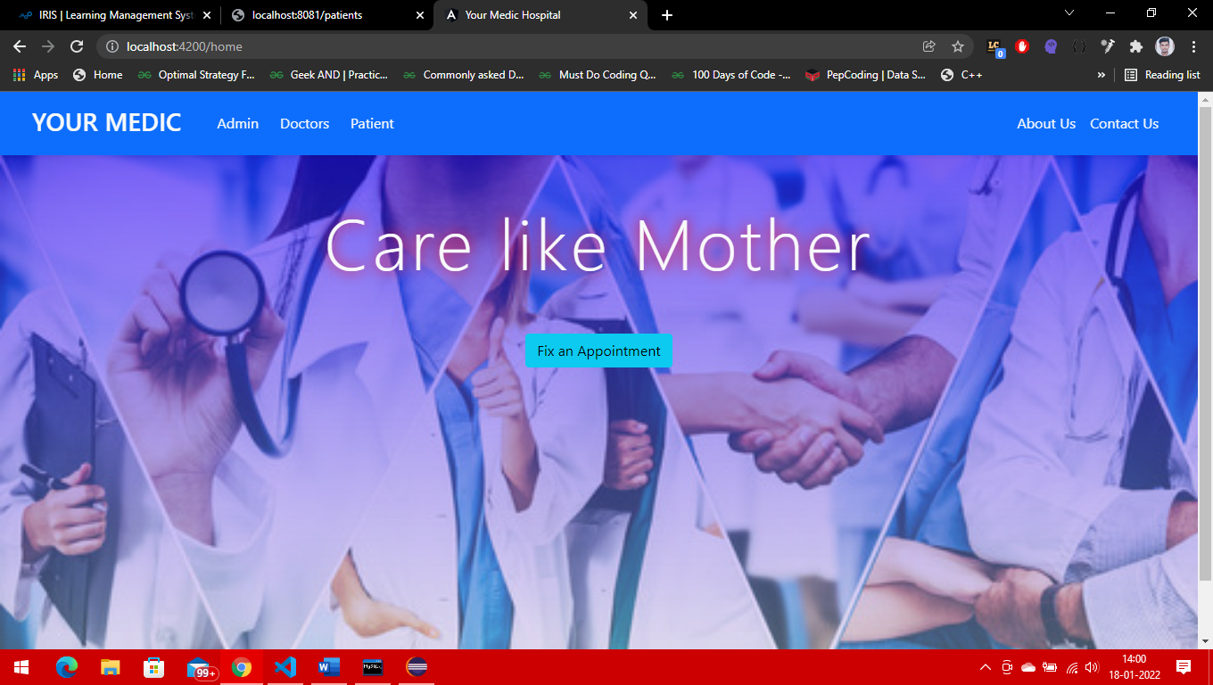

1. Develop Junit testing for all RESTAPI controller layer.

Doctor controller test

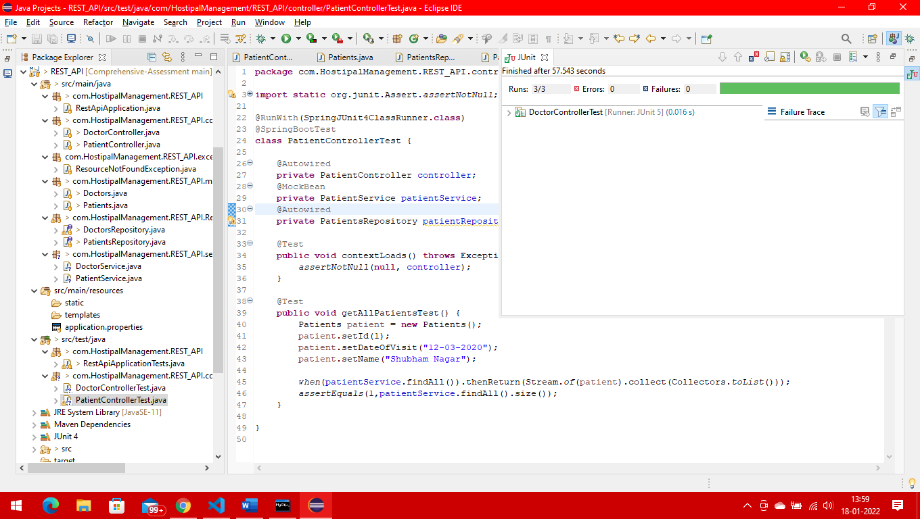

Doctor controller testcase

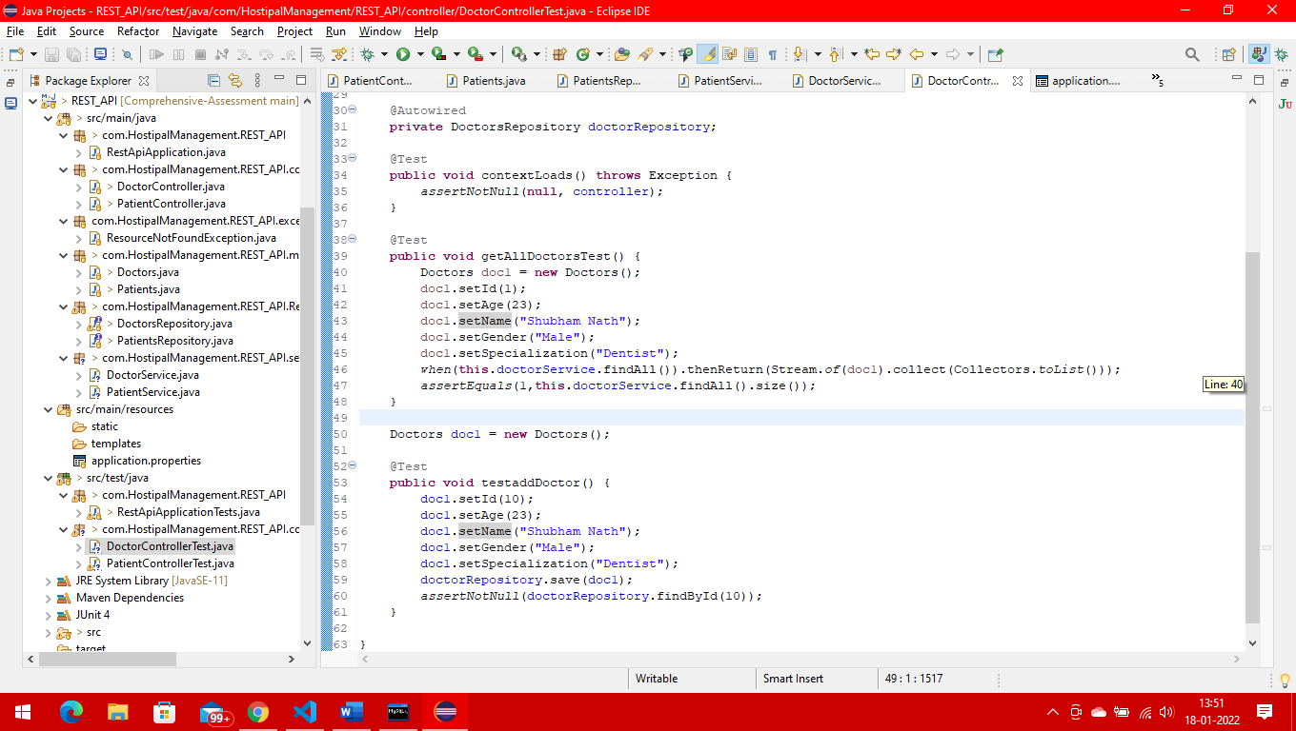

Patient controller testcase

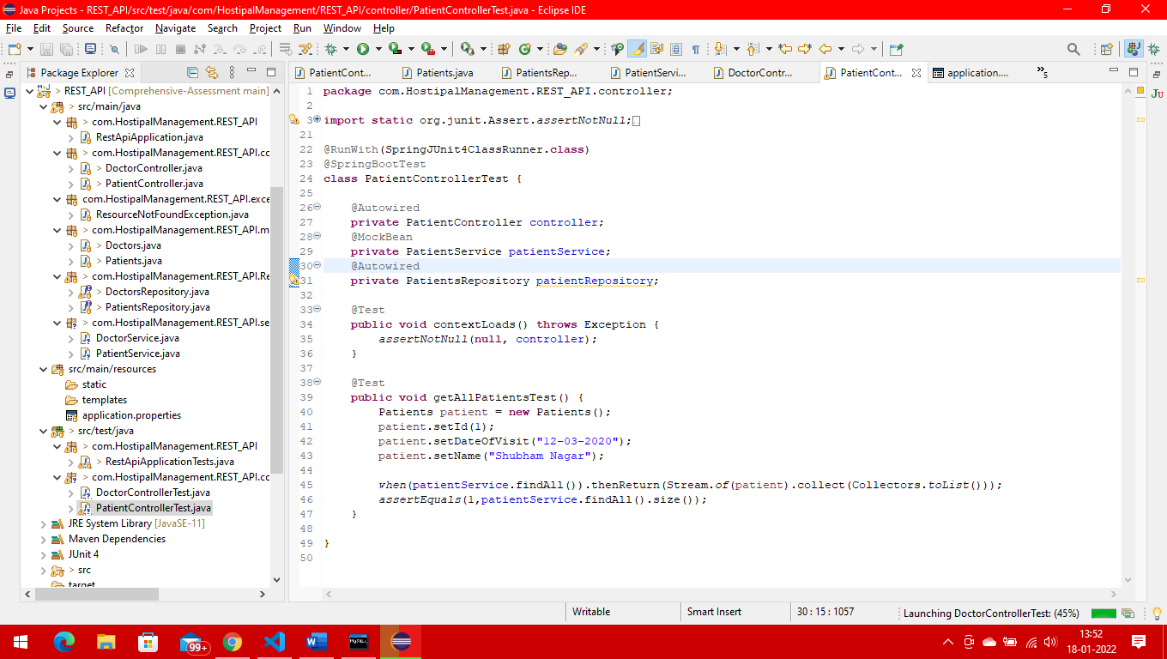

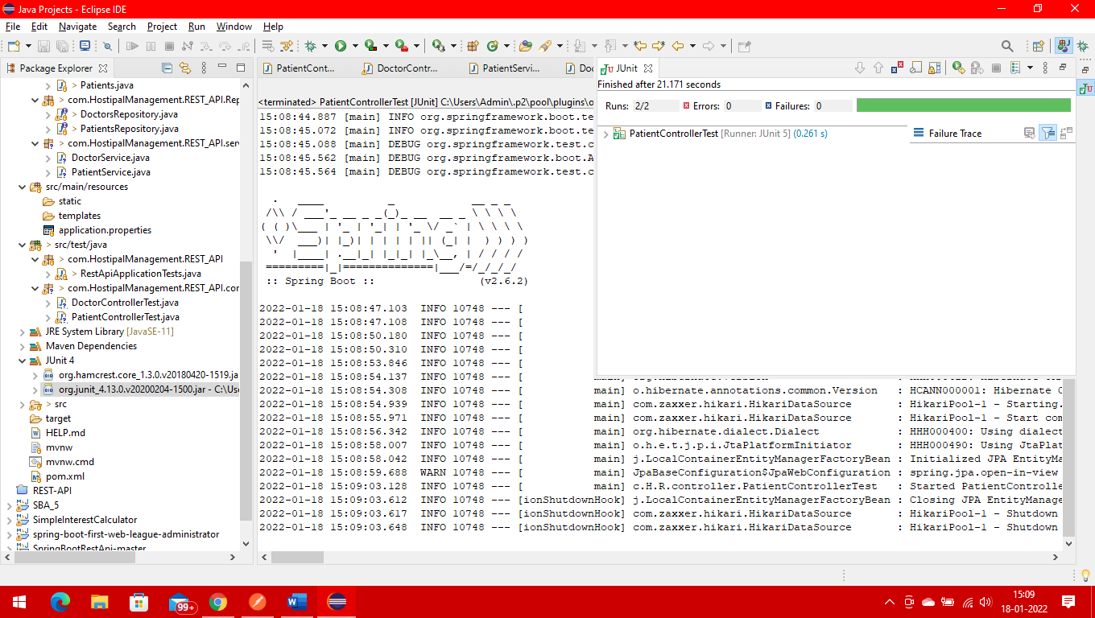

1. Write unit testing by using jasmine karma tool for angular code.

**Patient-list testing**

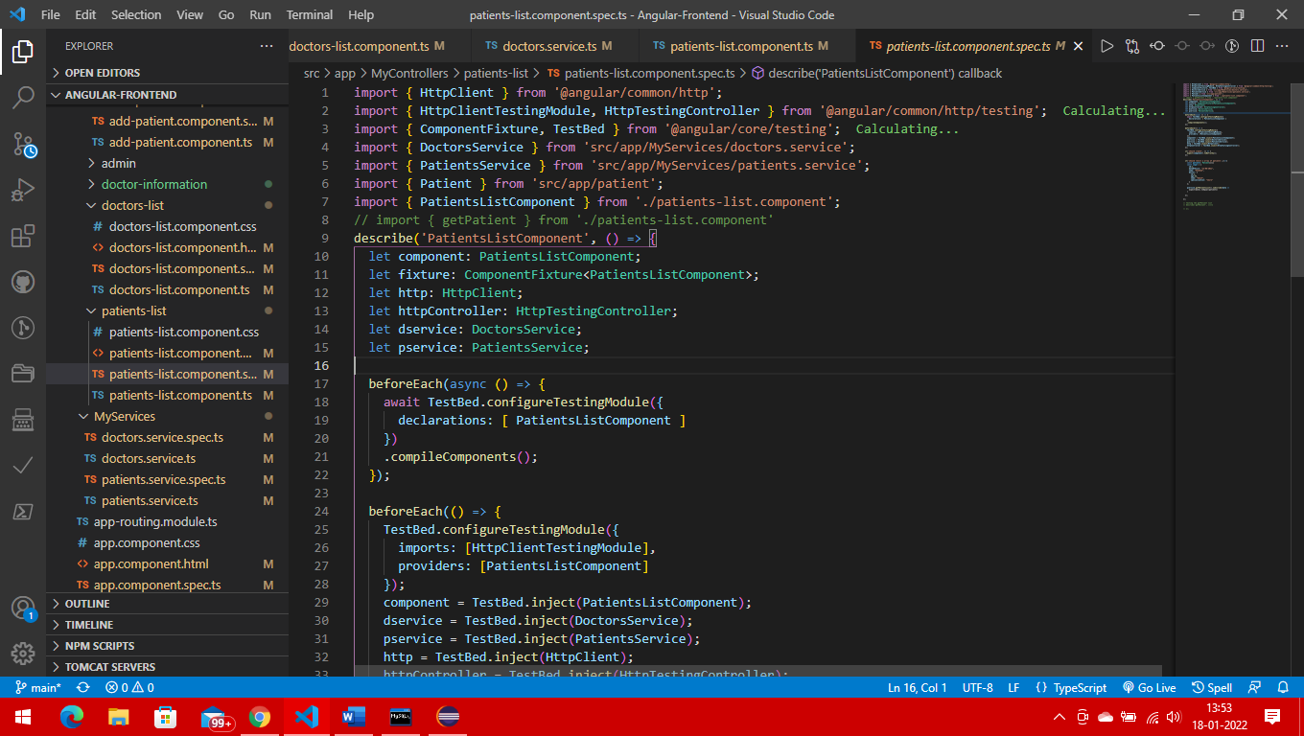

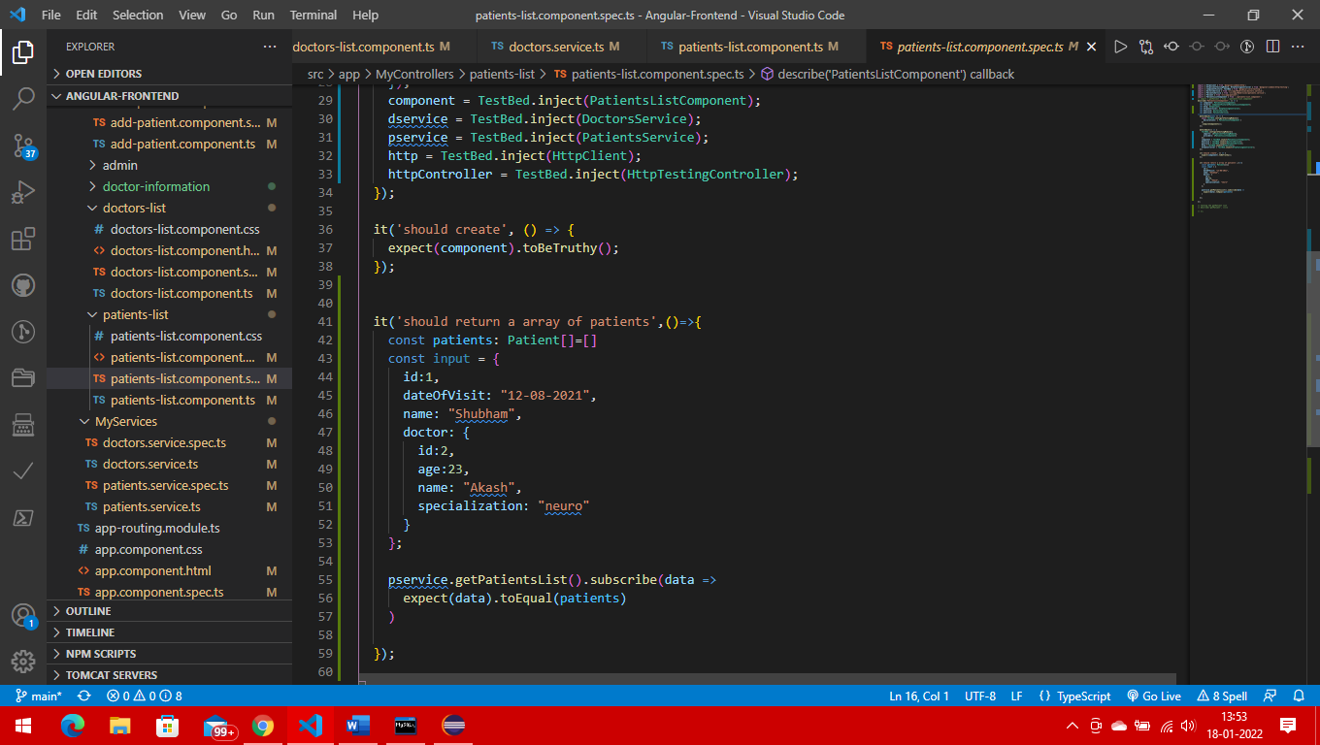

**Doctor list testing**

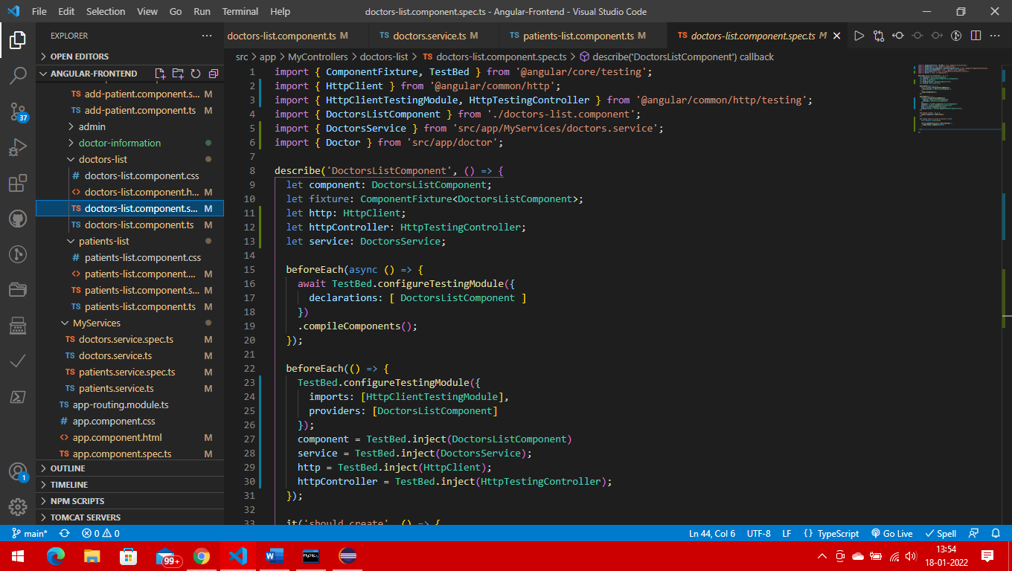

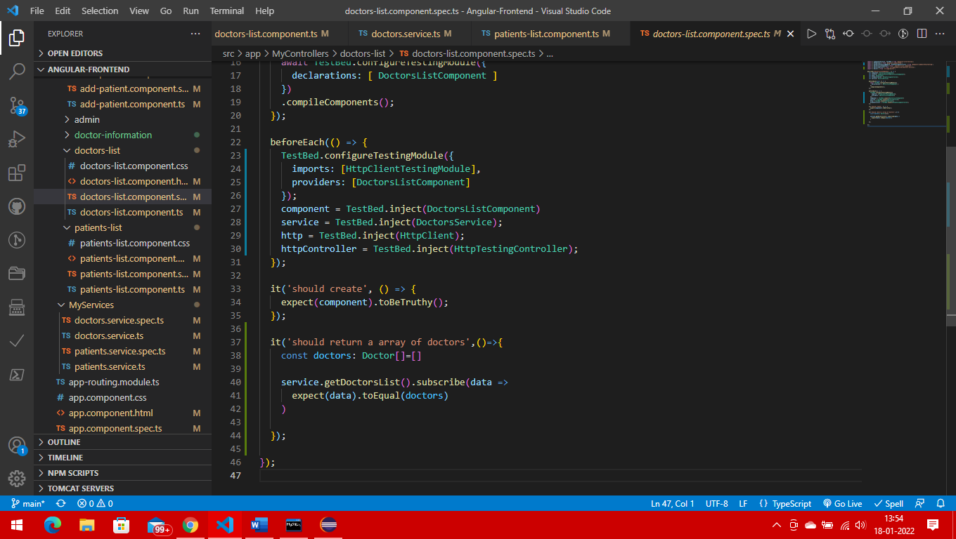

**Doctor service**

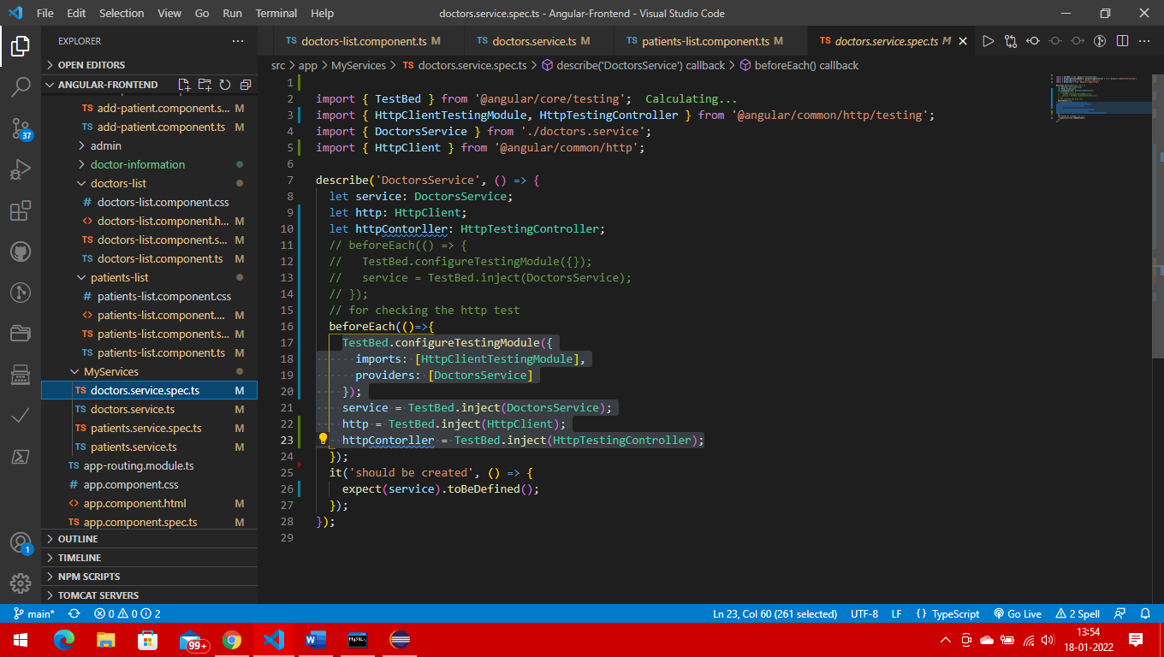

**Patient service**

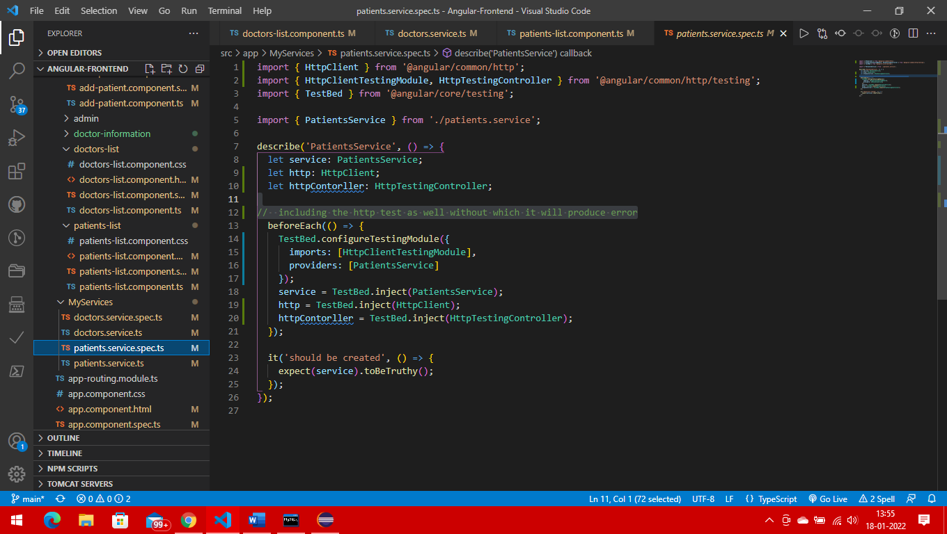

**App module testing**

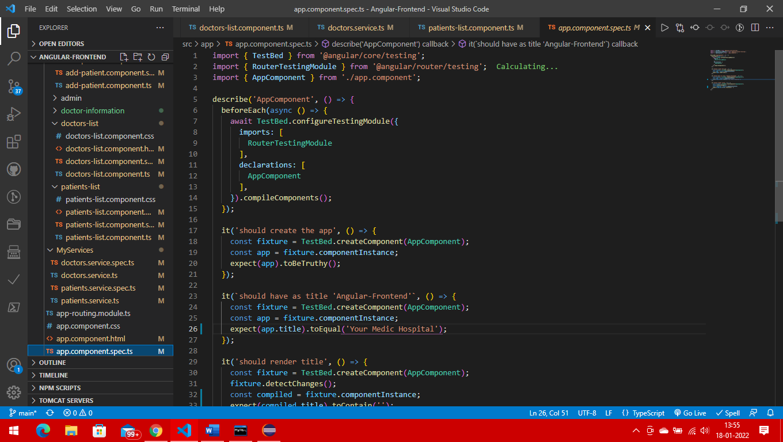

**Add patient testing**

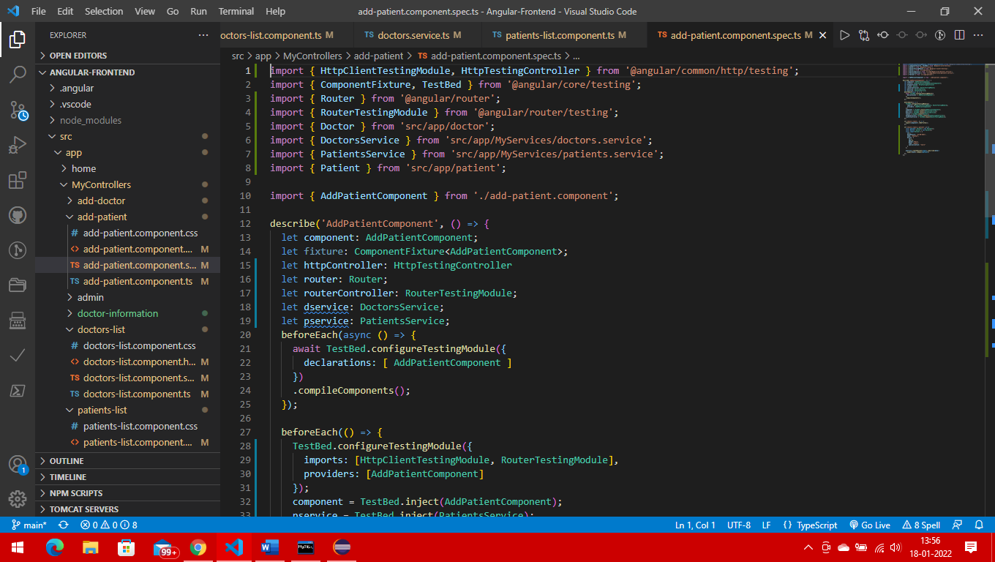

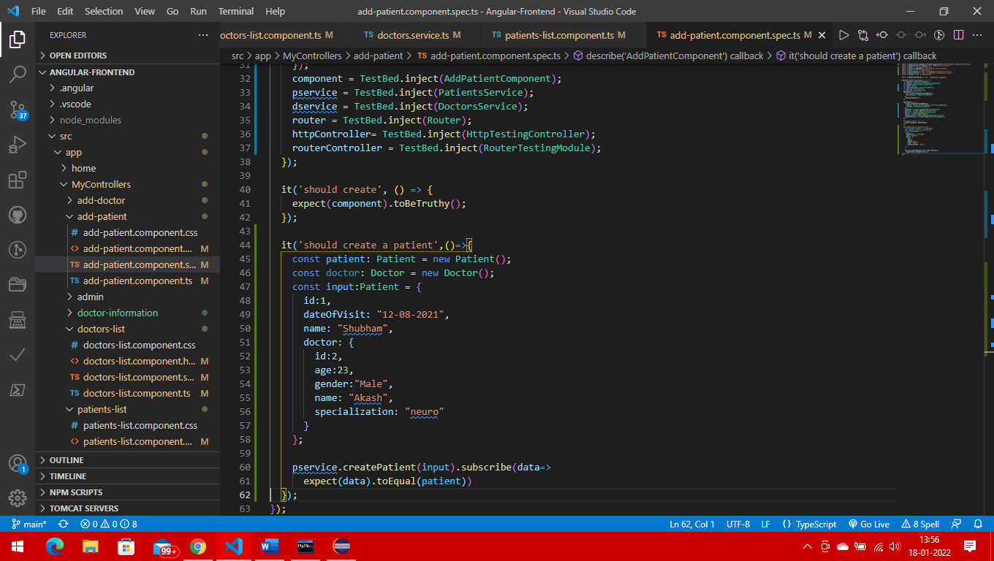

**Add doctor testing**

